Основи web (HTML, CSS). Кодування символів
Завдання 1. Протестуй сайт https://www.headhunterhairstyling.com/, знайшовши 3 баги; запиши їх в Google docs.

Bug 1
Title: Apostrophe is missing in “Mens Color” on the Services page
Environment:
macOS, Google Chrome
Preconditions:
The HeadHunter Hairstyling Services page is open.
HeadHunter Hairstyling | Services
Step to Reproduce:
Check the name of the “Mens Color” service in the “Color” section.
Actual Result:
The service name is displayed as “Mens Color”.
Attachment:

Expected Result:
The service name should be displayed as “Men’s Color”.
Severity: Trivial
Priority: Low
Bug 2
Title: Spelling mistake in “Cap Hightlights (Women)” on the Services page
Environment:
macOS, Google Chrome
Preconditions:
The HeadHunter Hairstyling Services page is open.
HeadHunter Hairstyling | Services
Step to Reproduce:
Check the name of the “Cap Hightlights (Women)” service in the “Color” section.
Actual Result:
The service name is displayed as “Cap Hightlights (Women)”.
Attachment:
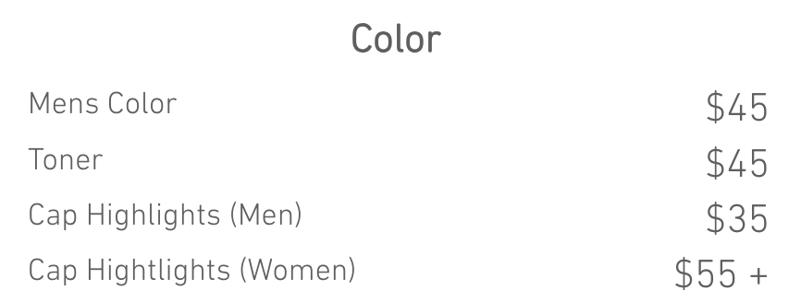
Expected Result:
The service name should be displayed as “Cap Highlights (Women)”.
Severity: Trivial
Priority: Low
Bug 3
Title: Image file names are displayed instead of user-friendly captions in the Products gallery
Environment:
macOS, Google Chrome
Preconditions:
The HeadHunter Hairstyling Services page is open.
HeadHunter Hairstyling | Services
Steps to Reproduce:
- Scroll down to the “Products” section.
- Hover the cursor over an image in the Products gallery.
- Check the caption displayed below the image.
- Navigate through other images in the gallery and check their captions.
Actual Result:
Technical image file names are displayed as captions for all images in the Products gallery (e.g., “redken-logo 1024x289”, “Synergy_Tan_logo 713x257” and “paulmitchell-large”).
Attachments:
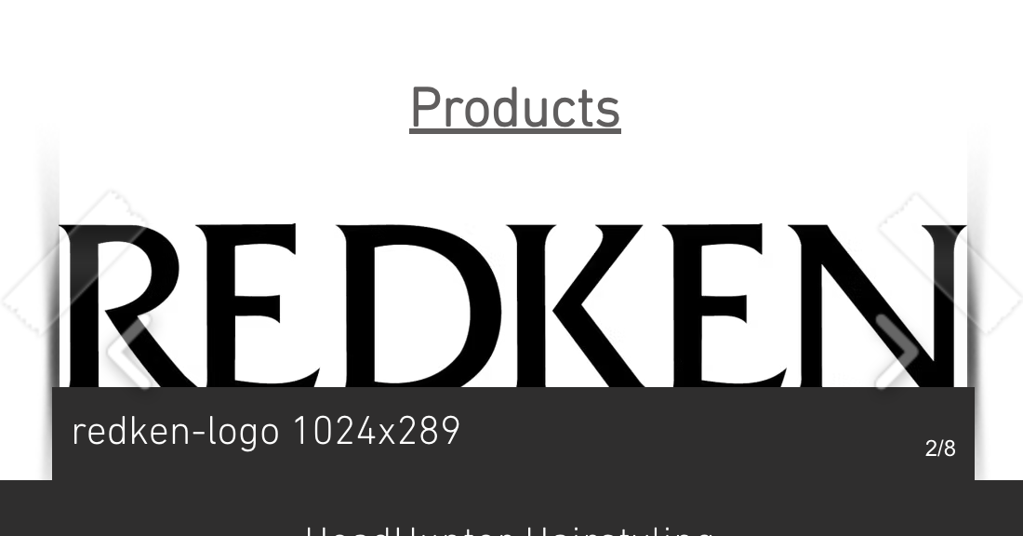
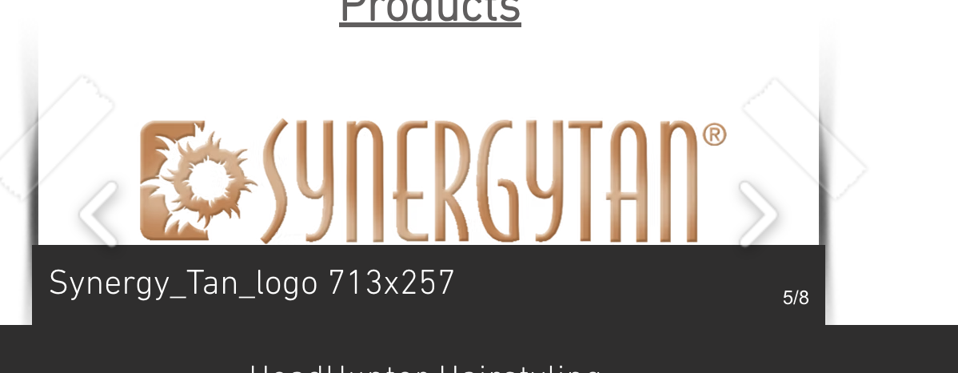

Expected Result:
User-friendly product or brand names should be displayed instead of technical image file names.
Severity: Minor
Priority: Low
Завдання 2. За допомогою Developer Tools визнач кодування символів, використаних на таких вебсторінках:
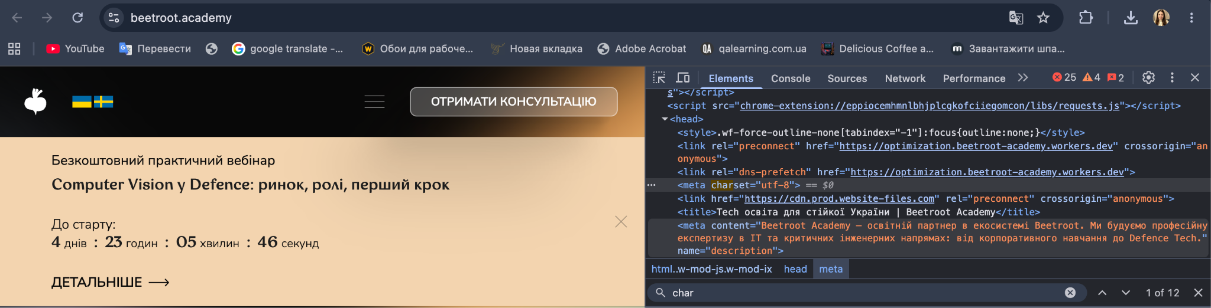
Beetroot Academy — UTF-8
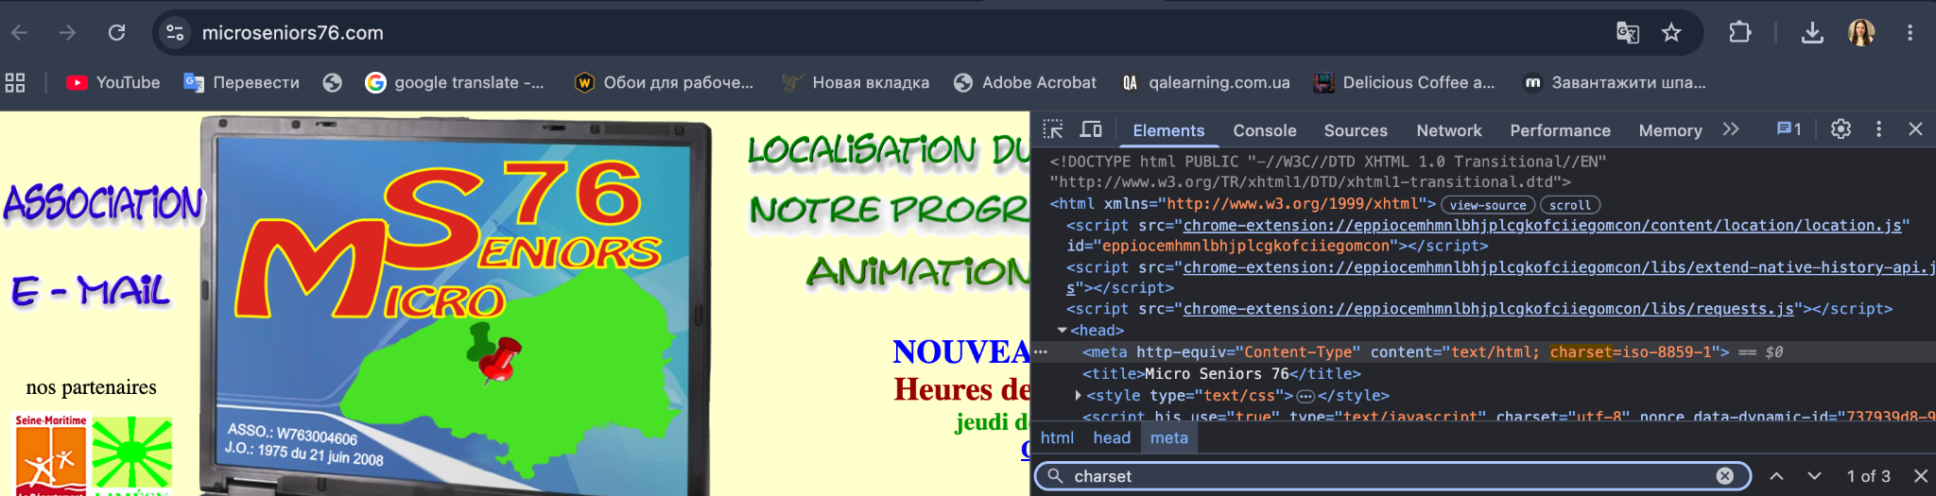
Micro Seniors 76 — ISO-8859-1
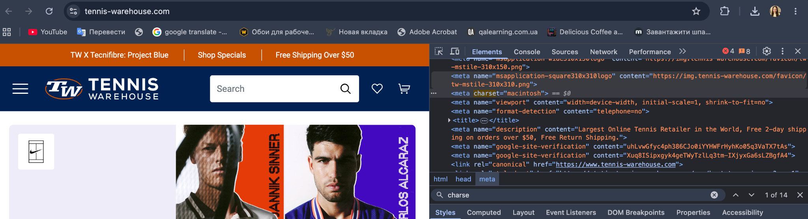
Tennis Warehouse — Macintosh
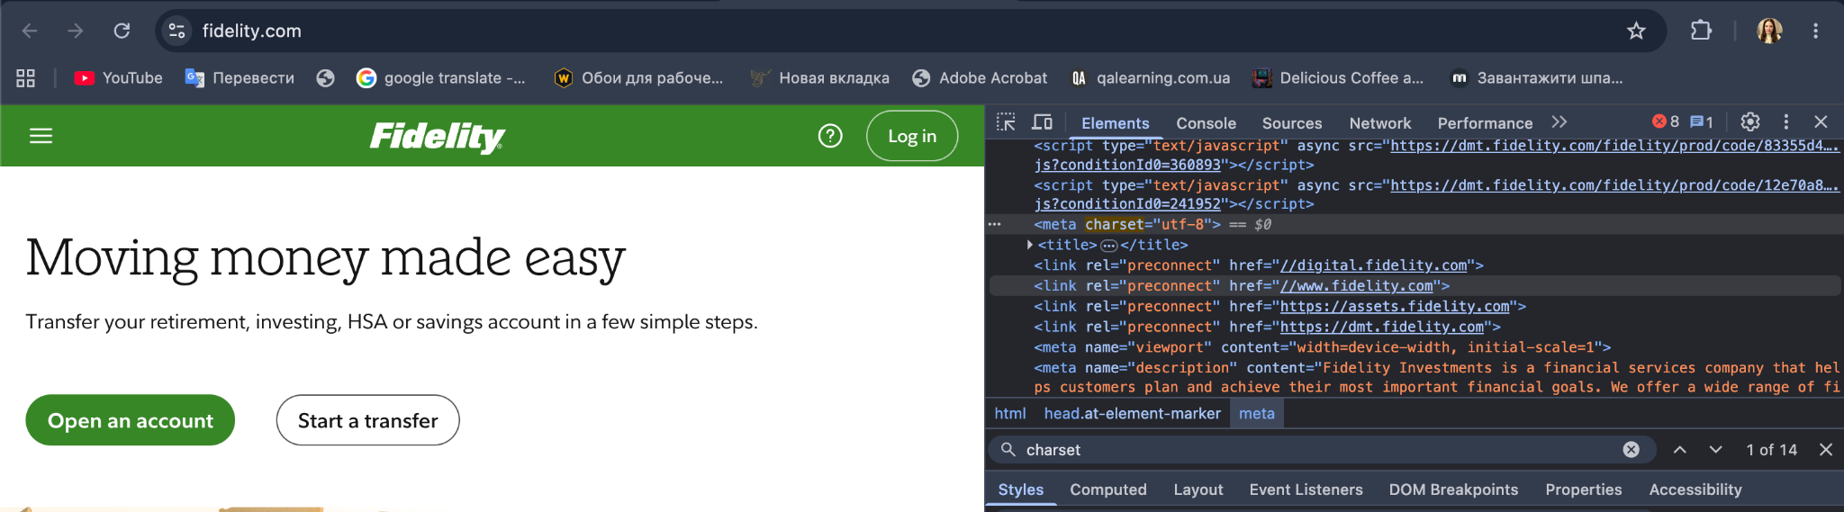
Fidelity Investments — UTF-8

Screenshots: Link to Google Drive
Screenshots Character Encoding

